# Hadoop on Azure Virtual Machines

## Cloudera CDH Edition

The framework will automate many of the steps for creating a Hadoop cluster on Windows Azure Virtual Machines. This framework is designed to deploy Cloudera’s CDH on Linux using Cloudera Manager.

The framework will automate the generation of the Azure based infrastructure, and walk through the manual steps to configure the environment. The framework is a blend of PowerShell based automation coupled with manual configuration.

The following instructions were tested on Ubuntu Server 12.04.3 LTS.

# Requirements

* Windows Azure PowerShell: <http://www.windowsazure.com/en-us/documentation/articles/install-configure-powershell/>
* PuTTY or another SSH tool: <http://www.putty.org>
* WinSCP or another tool to transfer files to the Linux image: <http://winscp.net/eng/index.php>
* Windows Azure Subscription with Storage Account. Steps below assist with creating the storage account and containers.
  + Create a public container in the account and move the st.pl perl script to the container

# Overview

1. Create the Management Node: Execute 1_Management_Node.ps1
   1. Create the Affinity Group (if it doesn’t exist)
   2. Create the Virtual Network (if it doesn’t exist)
   3. Create the Storage Account (if it doesn’t exist)
   4. Create the Management virtual machine
2. Create the Clone: Execute 2_Clone_Node.ps1
3. Manually configure the Management and Clone nodes
   1. Set root passwords
   2. Set up passwordless SSH between the Management Node and the Clone Node
   3. Set various server configurations to meet CDH requirements
   4. Add disk mount script
4. Prepare the Clone Node for provisioning
   1. Update waagent.conf
   2. Run waagent –deprovision
5. Create the Windows Azure Clone Image
   1. Stop the Clone Node
   2. Capture an image
6. Execute 3_Cluster_Nodes
   1. Creates multiple Windows Azure Virtual Machines using the Clone image
7. Update hosts and mount drives
8. Install Cloudera Manager on Management Node
9. Install CDH on cluster using Cloudera Manager

# Installing CDH on Windows Azure Virtual Machines

## Preparation

#### Windows Azure PowerShell

Download and install Windows Azure PowerShell: <http://www.windowsazure.com/en-us/downloads/>.

Follow online instructions for setting up the subscription with Windows Azure PowerShell: <http://www.windowsazure.com/en-us/documentation/articles/install-configure-powershell/>.

The PowerShell ISE (Integrated Scripting Environment) is often easier to use when developing and testing script execution. If you are in the traditional Windows Azure PowerShell interface, type ISE to open the PowerShell ISE.

#### Configure Windows Azure PowerShell Environment

Set PowerShell defaults for the new storage account. In the PowerShell ISE execute the following command.

**Set-AzureSubscription –SubscriptionName $subscriptionName   
–CurrentStorageAccount $clusterStorageAccount**

#### PuTTY

Download and install PuTTY or another SSH tool: <http://www.putty.org>

#### WinSCP

Download and install WinSCP: <http://winscp.net/eng/index.php>

#### Virtual Network Configuration Files

The way that the network is created depends on whether you have existing virtual networks defined. If your subscription has existing networks defined, you can merge the new network configuration into the existing configuration. If your subscription does not have existing networks defined, you can create the entire network from scratch. The 1_Management_Node.ps1 script in the following step automatically detects which scenario you have and acts accordingly.

The scripts assume that the virtual network subnet does not already exist. If you are using an existing virtual network and subnet, comment out the “create virtual network” sections from the 1_Management_Node.ps1 script.

**Known issue**

The virtual network create commands are called from both the 1_Management_Node.ps1 and 2_Clone_Node.ps1 script, and may produce errors if the network was already created. These errors may be ignored for the current version.

You will create two files as defined below. The script will use these files to add the new Virtual Network configuration settings.

1. Save the following XML block into a file named “C:\Temp\NetworkDef.xml”. Replace “*insert network address*” with the appropriate network address.

<VirtualNetworkSite name="placeholder-network" AffinityGroup="placeholder-affinitygroup">

<AddressSpace>

<AddressPrefix>*insert network address*</AddressPrefix>

</AddressSpace>

<Subnets>

<Subnet name="App">

<AddressPrefix>*insert network address*</AddressPrefix>

</Subnet>

</Subnets>

</VirtualNetworkSite>

1. Save the following XML block into a file named “C:\Temp\NetworkDef-Full.xml”. Replace “*insert network address*” with the appropriate network address.

<NetworkConfiguration xmlns:xsd="http://www.w3.org/2001/XMLSchema" xmlns:xsi="http://www.w3.org/2001/XMLSchema-instance" xmlns="http://schemas.microsoft.com/ServiceHosting/2011/07/NetworkConfiguration">

<VirtualNetworkConfiguration>

<Dns />

<VirtualNetworkSites>

<VirtualNetworkSite name="placeholder-network" AffinityGroup="placeholder-affinitygroup">

<AddressSpace>

<AddressPrefix>*insert network address*</AddressPrefix>

</AddressSpace>

<Subnets>

<Subnet name="App">

<AddressPrefix>*insert network address*</AddressPrefix>

</Subnet>

</Subnets>

</VirtualNetworkSite>

</VirtualNetworkSites>

</VirtualNetworkConfiguration>

</NetworkConfiguration>

## Create the Management Node

Execute the 1_Management_Node.ps1 script in Windows Azure PowerShell Integrated Shell Environment (ISE).

The script requires the following parameters representing the environment settings.

|  |  |
| --- | --- |
| Parameter name | Purpose |
| $imageName | The name of the Windows Azure image which will be used for provisioning the virtual machines. |
| $adminPassword | The password that will be generated in the virtual machines for the administrator of the virtual machines. |
| $adminUserName | The user name of the administrator account that will be created on the virtual machines. |
| $instanceSize | The size of the Windows Azure Virtual Machines (ie Small, Medium, Large, ExtraLarge, etc). Virtual machine sizes are detailed online: <http://msdn.microsoft.com/en-us/library/windowsazure/dn197896.aspx>. Large or ExtraLarge are recommended. |
| $diskSizeInGB | The size of the disk to attach to the virtual machines. |
| $numofDisks | The number of disks to attach to the virtual machines. |
| $vmNamePrefix | Naming convention for the virtual machines. All virtual machines will be named based on this prefix. |
| $cloudServicePrefix | Naming convention for the cloud services. In general, this will be the same as the $vmNamePrefix for ease of management. |
| $affinityGroupLocation | The Windows Azure data center where the virtual machines will be deployed. Choose a data center that is the same location as the storage account with the data to analyze.  Execute Get-AzureLocation from PowerShell or “azure vm location list” from the Azure Command Line to the the complete list of locations. |
| $affinityGroupName | The name of the affinity group (must be unique in your subscription). |
| $affinityGroupDescription | The description for the affinity group. |
| $affinityGroupLabel | The label for the affinity group. |
| $virtualNetworkName | The name for the virtual network (must be unique in your subscription). |
| $virtualNetworkName | The name for the virtual network (must be unique in your subscription). |
| $virtualSubnetName | The name of the virtual subnet. |
| $storageAccountName | The name of the storage account that will be used or created. |

#### Sample Execution Script

.\1_Management_Node.ps1 -imageName "Oracle Linux 6.4.0.0.0" -adminUserName "clusteradmin" -adminPassword "Password.1" -instanceSize "Large" -diskSizeInGB 100 -numOfDisks 2 -vmNamePrefix "CDHNode" -cloudServicePrefix "CDHNode" -affinityGroupLocation "East US" -affinityGroupName "AGCDH" -affinityGroupDescription "Affinity Group used for CDH on Azure VM" -affinityGroupLabel "Hadoop on Azure VM AG CDH" -virtualNetworkName "Hadoop-NetworkCDH" -virtualSubnetname "App" -storageAccountName "cdhstorage"

## Create the Clone

Execute the 2_Clone_Node.ps1 script in Windows Azure PowerShell Integrated Shell Environment (ISE).

The script requires the following parameters representing the environment settings.

|  |  |
| --- | --- |
| Parameter name | Purpose |
| $imageName | The name of the Windows Azure image which will be used for provisioning the virtual machines. |
| $adminPassword | The password that will be generated in the virtual machines for the administrator of the virtual machines. |
| $adminUserName | The user name of the administrator account that will be created on the virtual machines. |
| $instanceSize | The size of the Windows Azure Virtual Machines (ie Small, Medium, Large, ExtraLarge, etc). Virtual machine sizes are detailed online: <http://msdn.microsoft.com/en-us/library/windowsazure/dn197896.aspx>. Medium or larger is recommended. |
| $diskSizeInGB | The size of the disk to attach to the virtual machines. |
| $numofDisks | The number of disks to attach to the virtual machines. |
| $vmNamePrefix | Naming convention for the virtual machines. All virtual machines will be named based on this prefix. |
| $cloudServicePrefix | Naming convention for the cloud services. In general, this will be the same as the $vmNamePrefix for ease of management. |
| $affinityGroupLocation | The Windows Azure data center where the virtual machines will be deployed. Choose a data center that is the same location as the storage account with the data to analyze.  Execute Get-AzureLocation from PowerShell or “azure vm location list” from the Azure Command Line to the the complete list of locations. |
| $affinityGroupName | The name of the affinity group (must be unique in your subscription). |
| $affinityGroupDescription | The description for the affinity group. |
| $affinityGroupLabel | The label for the affinity group. |
| $virtualNetworkName | The name for the virtual network (must be unique in your subscription). |
| $virtualNetworkName | The name for the virtual network (must be unique in your subscription). |
| $virtualSubnetName | The name of the virtual subnet. |
| $storageAccountName | The name of the storage account that will be used or created. |

#### Sample Execution Script

.\2_Clone_Node.ps1 -imageName "Oracle Linux 6.4.0.0.0" -adminUserName "clusteradmin" -adminPassword "Password.1" -instanceSize "Large" -diskSizeInGB 100 -numOfDisks 2 -vmNamePrefix "cdhNode" -cloudServicePrefix "cdhNode" -affinityGroupLocation "East US" -affinityGroupName "AGCDH" -affinityGroupDescription "Affinity Group used for CDH on Azure VM" -affinityGroupLabel "Hadoop on Azure VM AG CDH" -virtualNetworkName "Hadoop-NetworkCDH" -virtualSubnetname "App" -storageAccountName "cdhstorage"

**Known issue**

The virtual network create commands are called from both the 1_Management_Node.ps1 and 2_Clone_Node.ps1 script, and may produce errors if the network was already created. These errors may be ignored for the current version.

## Manually configure the Management and Clone nodes

The Management Node is named $vmNamePrefix followed by 0, and the Clone Node is named $vmNamePrefix followed by “c”. You will use PuTTY to configure these nodes.

In addition to the DNS name, you may need the Management Node private IP and the Clone Node private IP to proceed with this section. The virtual machine IP addresses can be found by viewing the properties of the virtual machine in the [Windows Azure Management Portal](https://manage.windowsazure.com/).

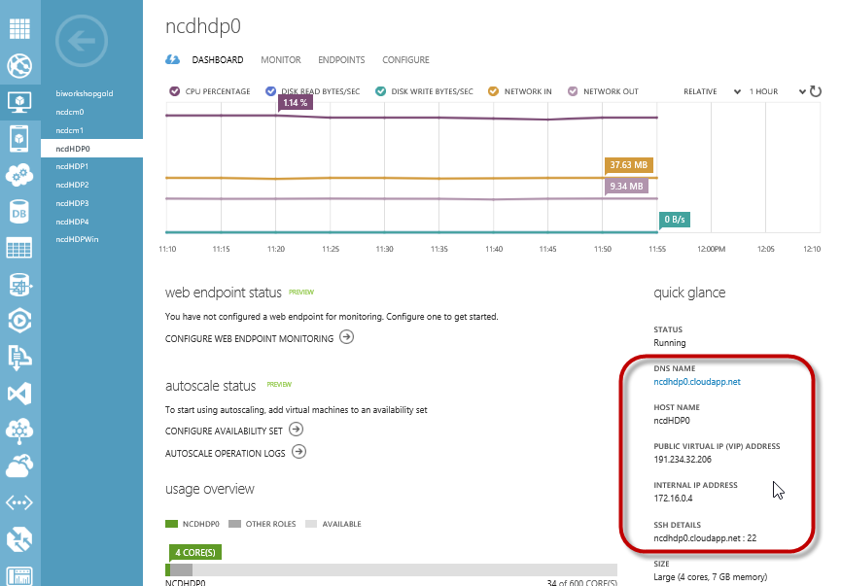

Open PuTTY and input port 22 with the Management Node public IP address or the DNS name. Click Open.

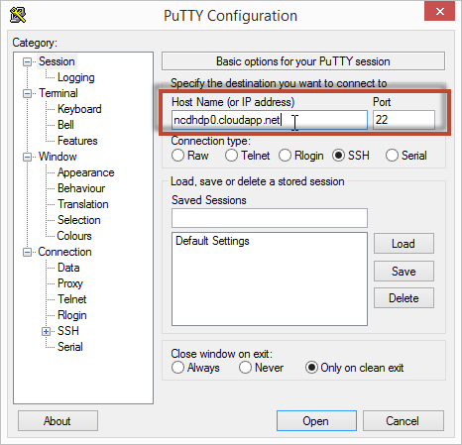

You will be prompted for a login and password. Enter the value used in the parameter $adminUserName with the password you provided for the parameter $adminPassword.

### Set root passwords

The first steps will be to set the root passwords on both the Management Node and Clone Node. You are currently connected to the Management Node.

Elevate to root. Enter the password for the $adminUserName when prompted. Update the root password. Enter the new password when prompted.

**sudo –s**

**passwd**

Enter the following to move to the Clone Node, or open a second PuTTY window to connect to the Clone Node. Enter the password for the adminUserName when prompted.

**ssh <adminUserName>@<Clone Node Hostname>.cloudapp.net**

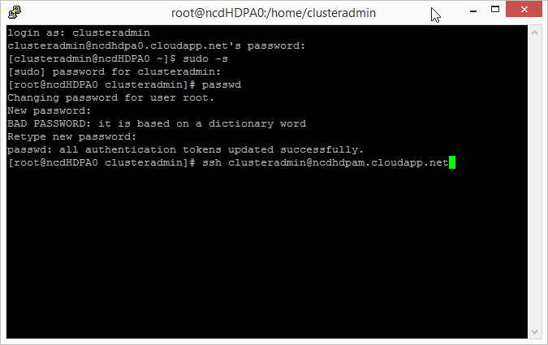

Elevate to root. Enter the password for the $adminUserName when prompted.

Update the root password. Enter the new password when prompted.

**sudo –s**

**passwd**

With both root passwords set we can now configure the nodes for the cluster.

### Set up passwordless SSH between the Management Node and the Clone Node

In the Management Node generate the key.

**ssh-keygen**

Accept the default file location when prompted (press enter). Press enter to create the key without a passphrase. The public key is stored in .ssh/id_rsa.pub, and the private key is id_rsa. You will use the private key later during the CDH installation. At this time you will copy the public key to the Clone Node to enable passwordless ssh.

Copy the key to the Clone node and Management Node (self-referencing), enter the root password when prompted.

**ssh-copy-id -i /root/.ssh/id_rsa.pub root@<Clone Node Hostname>.cloudapp.net**

**ssh-copy-id -i /root/.ssh/id_rsa.pub root@<Management Node Hostname>.cloudapp.net**

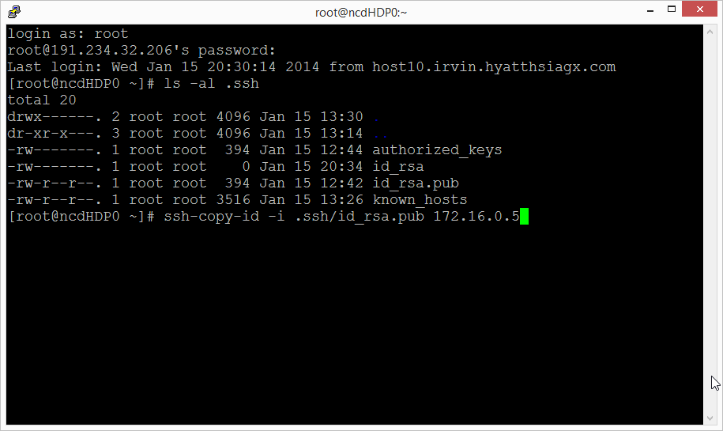

To test the keys were set up correctly, type the following and validate that you are not prompted for a password.

**ssh <Management Node Hostname>.cloudapp.net**

**ssh <Clone Node Hostname>.cloudapp.net**

Note that the passwordless ssh is not reciprocal. You will be prompted for a password when you are returning to the Management Node from the Clone Node.

Return to the Management Node to configure the final settings.

**ssh <Management Node Hostname>.cloudapp.net**

### Add Script to Mount Disks

The disks will be mounted later in the process. Load the script to the image.

Open WinSCP and connect to the Management Node as root. Drag and drop the makefilesystem.sh script from the framework source files to the Management Node root folder. Connect to the Clone node as root and repeat moving the makefilesystem.sh file to the Clone Node root folder.

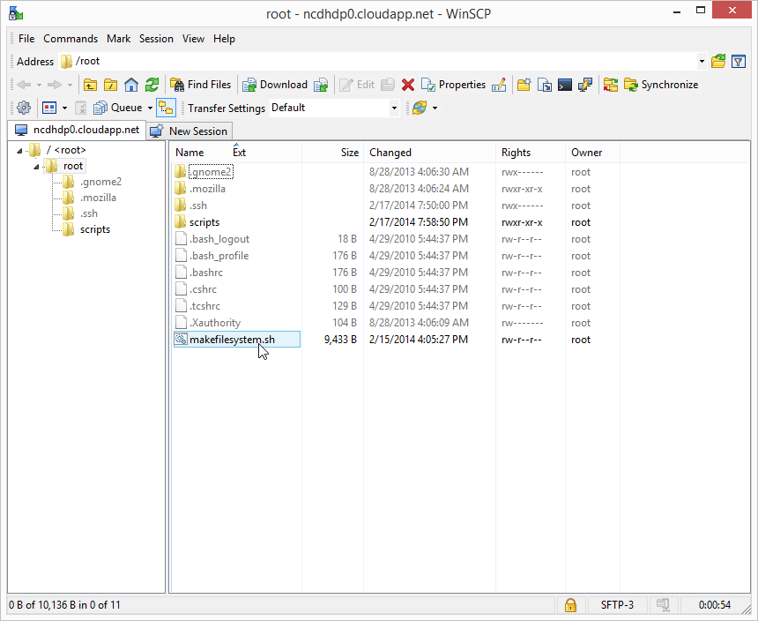

### Update Server Configuration Settings

Using PuTTY connect to the Management Node and Clone Node to configure the nodes. Execute the following to move and secure the script, install and use dos2unix to convert makefilesystem.sh file to a Linux friendly format. The final steps will configure prerequisite server settings.

CentOS, Oracle

**mkdir /root/scripts**

**mv makefilesystem.sh /root/scripts/makefilesystem.sh**

**chmod 755 /root/scripts/makefilesystem.sh**

**yum -y install dos2unix**

**dos2unix /root/scripts/makefilesystem.sh /root/scripts/makefilesystem.sh**

**#disable firewall**

**ufw disable**

**#start ntp service**

**yum -y install ntp**

**chkconfig ntpd on**

**ntpdate pool.ntp.org**

Ubuntu

**mkdir /root/scripts**

**mv makefilesystem.sh /root/scripts/makefilesystem.sh**

**chmod 755 /root/scripts/makefilesystem.sh**

**apt-get -y install dos2unix**

**dos2unix /root/scripts/makefilesystem.sh /root/scripts/makefilesystem.sh**

**#disable firewall**

**ufw disable**

**#start ntp service**

**apt-get -y install ntp**

**chkconfig ntpd on**

**ntpdate pool.ntp.org**

### Clone Node Windows Azure Linux Agent

Connect to the Clone Node using PuTTY. **This will not be run on the Management Node!** Set up the virtual machine for provisioning as an image. Open the waagent.conf file.

**vi /etc/waagent.conf**

If you are new to vi, type i to enter insert mode. Navigate to the correct line in the file and update. Press Esc to exit insert mode, type :wq to save changes and return to the command prompt.

Change the following settings by typing i to enter insert mode:

**Provisioning.DeleteRootPassword=n**

**Provisioning.RegenerateSshHostKeyPair=n**

Press esc to exit insert mode. Type :wq and press enter to save and close the file.

Run the Windows Azure Linux Agent.

**waagent –deprovision**

Return to the Management Node.

**ssh <Management Node Hostname>.cloudapp.net**

## Capture the Clone Image

Open the Windows Azure Management Portal and navigate to the dashboard of the Clone Node virtual machine. Shut down the Clone Node virtual machine. After the machine is stopped, click Capture to create an image.

## Create the Cluster

Open the 3_Cluster_Nodes.ps1 script in Windows Azure PowerShell Integrated Shell Environment (ISE).

Execute the script with the parameters representing the appropriate environment settings.

|  |  |
| --- | --- |
| Parameter name | Purpose |
| $imageName | The name of the Clone image which will be used for provisioning the virtual machines. |
| $adminPassword | The password that will be generated in the virtual machines for the administrator. |
| $adminUserName | The user name of the administrator account. |
| $instanceSize | The size of the Windows Azure Virtual Machines (ie Small, Medium, Large, ExtraLarge, etc). Virtual machine sizes are detailed online: <http://msdn.microsoft.com/en-us/library/windowsazure/dn197896.aspx>. Large or ExtraLarge are recommended, depending on the size of your cluster and the services you plan to employ. |
| $diskSizeInGB | The size of the disk to attach to the virtual machines. |
| $numofDisks | The number of disks to attach to the virtual machines |
| $vmNamePrefix | Naming convention for the virtual machines. All virtual machines will be named based on this prefix. |
| $cloudServicePrefix | Naming convention for the cloud services. In general, this will be the same as the $vmNamePrefix for ease of management. |
| $numNodes | The total number of virtual machines to create for the cluster. |
| $affinityGroupLocation | The Windows Azure data center where the virtual machines will be deployed. |
| $virtualNetworkName | The name for the virtual network (must be unique in your subscription). |
| $virtualSubnetName | The name of the virtual subnet. |
| $storageAccountName | The name of the storage account to use for the VHD storage. |
| $hostsfile | The location of the hosts file that is generated during the cluster creation. This is optional, with a default of “.\hosts.txt” |
| $mntscript | The location of the mountdrive file that is generated during the cluster creation. This is option, with a default of “.\mountdrive.sh” |

#### Sample Execution Script

.\3_Cluster_Nodes.ps1 -imageName "cdhnodem" -adminUserName "clusteradmin" -adminPassword "Password.1" -instanceSize "ExtraLarge" -diskSizeInGB 100 -numofDisks 2 -vmNamePrefix " CDHNode" -cloudServicePrefix " CDHNode" -numNodes 8 -affinityGroupName "AGCDH" -virtualNetworkName "Hadoop-NetworkCDH" -virtualSubnetname "App" -storageAccountName "App" -hostsfile ".\hosts.txt" -mntscript ".\mountdrive.sh"

At the completion of the script, you will have a set of virtual machines on which to install Hadoop.

To test the virtual machines were generated correctly, open a PuTTY connection from the Management node and connect to a few of the machines to verify the host name and to verify passwordless ssh is working:

**ssh <Cluster Machine Hostname>.cloudapp.net**

**hostname**

## Update Cluster Machines

Use WinSCP to copy the following files to root directory of the Management Node: hosts.txt, mountdrive.sh, updatehosts.sh.

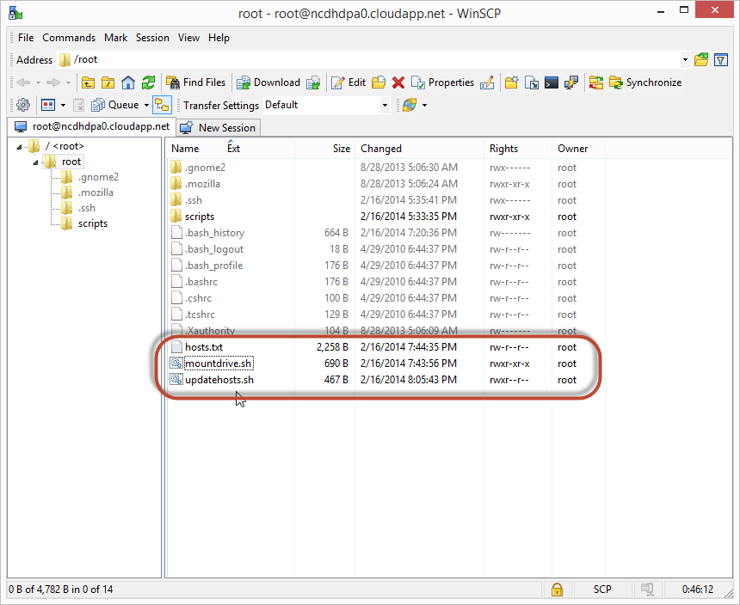

Run the conversion of the files with dos2unix. After the files are loaded in the Management Node, secure the files.

**dos2unix hosts.txt hosts.txt**

**dos2unix mountdrive.sh mountdrive.sh**

**dos2unix updatehosts.sh updatehosts.sh**

**chmod 755 updatehosts.sh**

**chmod 755 mountdrive.sh**

Execute updatehosts.sh to update /etc/hosts with the information from the hosts.txt file. Execute mountdrive.sh to mount the drives on all machines in the cluster.

**./updatehosts.sh**

**./mountdrive.sh**

## Install Cloudera Manager and CDH

This is a summary of the instructions from Cloudera’s online documentation: <http://www.cloudera.com/content/cloudera-content/cloudera-docs/CM4Ent/latest/Cloudera-Manager-Installation-Guide/cmig_install_path_A.html?scroll=cmig_topic_6_5>

Open an SSH session in PuTTY to the Management Node.

If you are using the gallery image “Oracle Linux 6.4.0.0.0” install wget.

**yum install wget**

Download and install Cloudera Manager:

**wget http://archive.cloudera.com/cm5/installer/latest/cloudera-manager-installer.bin**

**chmod u+x cloudera-manager-installer.bin**

**./cloudera-manager-installer.bin**

From Windows Azure Management Portal, navigate to the management node virtual machine and select Endpoints. Add an endpoint for port 7180.

Open the browser and navigate to http://<Management Node Hostname>:7180

When prompted, log in as admin with password admin.

In general, follow the prompts to install.